# Unit 0 – Review: Basic Scientific Measurement and Problem Solving Techniques

# Learning Targets

| **Objectives** |  |
| --- | --- |
| 1. Recognize that instruments have a limit to their precision.    1. Record the value a measurement in a manner consistent with the limit of precision of the equipment, i.e. length, volume, temperature, mass, etc.    2. Recognize the precision of the instrument from the correctly reported measurements. |  |
| 1. Determine the number of significant figures in a given measured value. |  |
| 1. Round off calculated values to the appropriate number of significant figures. |  |
| 1. Demonstrate use of scientific notation. |  |
| 1. Demonstrate use of graphing to evaluate laboratory data. Be able to determine independent and dependent variables. Be able to determine slope and equation of lines. |  |
| 1. Understand meaning of percent with regards to decimal, fractional and ratios |  |
| 1. Be able to use factor-label method to convert between metric units and proportional relationships |  |

|  |
| --- |
| **Concepts and Skills Review** |

There are two kinds of numbers in the world**:**

* **exact:**
  + example: There are exactly 12 eggs in a dozen.
  + example: Most people have exactly 10 fingers and 10 toes.
* **inexact numbers:**
  + example: any measurement.  
    If I quickly measure the width of a piece of notebook paper, I might get 220 mm. If I am more precise, I might get 216 mm. An even more precise measurement would be 215.6 mm.

**Reading Scales**

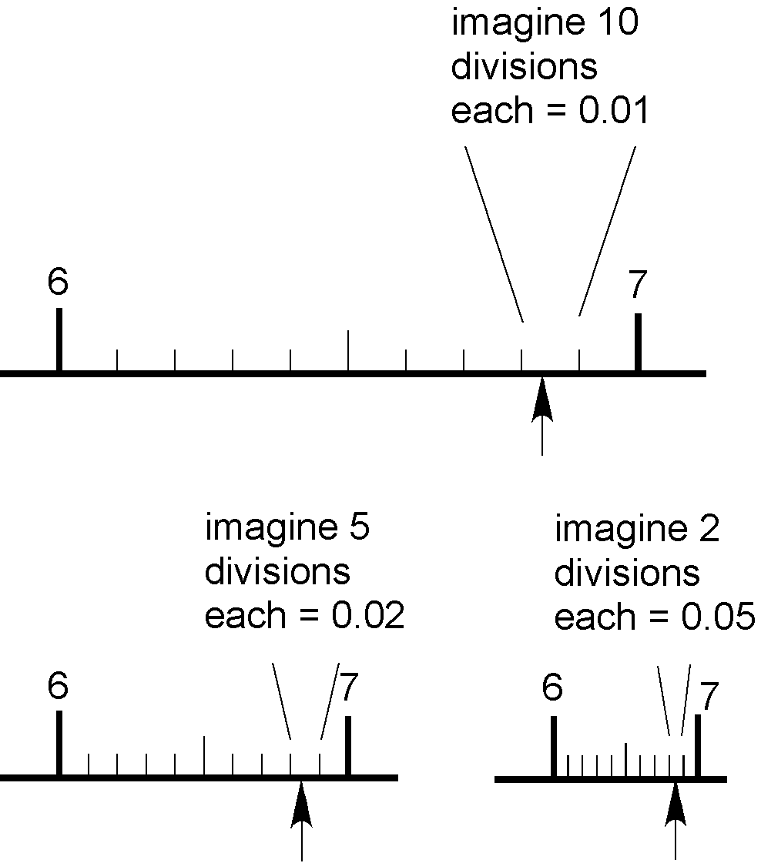

**PRECISION VERSUS ACCURACY**

**Accuracy** refers to how closely a measured value agrees with the correct value.  
**Precision** refers to how closely individual measurements agree with each other.

| image | mr-sf-2 | mr-sf-3 |
| --- | --- | --- |
| accurate (the average is accurate) not precise | precise not accurate | accurate and precise |

In any measurement, the number of significant figures is critical. The number of significant figures is the number of digits believed to be correct by the person doing the measuring. It includes one **estimated** digit. So, does the concept of significant figures deal with precision or accuracy?

Let's look at an example where significant figures are important**:** measuring volume in the laboratory. This can be done in many ways**:** using either a beaker with volumes marked on the side, or a graduated cylinder. Which glassware would give you the most precise volume measurement? Let's figure out the volume for each one and its associated error. This will give us the number of figures that are significant. Recall: the number of significant figures includes one estimated digit.

**A rule of thumb:** read the volume to 1/10 or 0.1 of the smallest division. (This rule applies to any measurement.) This means that the error in reading (called the reading error) is plusmins1/10 or 0.1 of the smallest division on the glassware. If you are less sure of yourself, you can read to 1/5 or 0.2 of the smallest division.

| **Beaker** | beaker | The smallest division is 10 mL, so we can read the volume to plusmins1/10 of 10 mL or plusmins1 mL. The volume we read from the beaker has a reading error of plusmins1 mL.  The volume in this beaker is 47 plusmins1 mL. You might have read 46 mL; your friend might read the volume as 48 mL. All the answers are correct within the reading error of plusmins1 mL.  So, How many significant figures does our volume of 47 plusmins1 mL have? Answer - 2! The "4" we know for sure plus the "7" we had to estimate. |
| --- | --- | --- |

| **Graduated Cylinder** | gradcyl | First, note that the surface of the liquid is curved. This is called the meniscus. This phenomenon is caused by the fact that water molecules are more attracted to glass than to each other (adhesive forces are stronger than cohesive forces). When we read the volume, we read it at the BOTTOM of the meniscus.  The smallest division of this graduated cylinder is 1 mL. Therefore, our reading error will be plusmins0.1 mL or 1/10 of the smallest division. An appropriate reading of the volume is 36.5 plusmins0.1 mL. An equally precise value would be 36.6 mL or 36.4 mL.  How many significant figures does our answer have? 3! The "3" and the "6" we know for sure and the "5" we had to estimate a little. |
| --- | --- | --- |

**Conclusion:** The number of significant figures is directly linked to a measurement. If a person needed only a rough estimate of volume, the beaker volume is satisfactory (2 significant figures), otherwise one should use the graduated cylinder (3 significant figures).

So, does the concept of significant figures deal with precision or accuracy? Hopefully, you can see that it really deals with precision only. Consider measuring the length of a metal rod several times with a ruler. You will get essentially the same measurement over and over again with a small reading error equal to about 1/10 of the smallest division on the ruler. You have determined the length with high precision. However, you don't know if the ruler was accurate to begin with. Perhaps it was a plastic ruler left in the hot Texas sun and was stretched. You don't know the accuracy of your measuring device unless you calibrate it, i.e. compare it against a ruler you knew was accurate. Note: in the laboratory, a good analytical chemist always calibrates her volumetric glassware before using it by weighing a known volume of liquid dispensed from the glassware. By dividing the mass of the liquid by its density, she can determine the actual volume and hence the accuracy of the glassware.

**Rules for Working with Significant Figures:**

1. Leading zeros are never significant.   
   Imbedded zeros are always significant.   
   Trailing zeros are significant only if the decimal point is specified.   
   Hint: Change the number to scientific notation. It is easier to see.
2. **Addition or Subtraction:**The last digit retained is set by the first doubtful digit.
3. **Multiplication or Division:**The answer contains no more significant figures than the **least** accurately known number.

**EXAMPLES:**

|  | **Example** | **Number of Significant Figures** | **Scientific Notation** |
| --- | --- | --- | --- |
|  | 0.00682 | 3 | 6.82 x 10**-**3 | Leading zeros are not significant. |
|  | 1.072 | 4 | 1.072 (x 100) | Imbedded zeros are always significant. |
|  | 300 | 1 | 3 x 102 | Trailing zeros are significant only if the decimal point is specified. |
|  | 300**.** | 3 | 3.00 x 102 |  |
|  | 300**.**0 | 4 | 3.000 x 102 |  |

**EXAMPLES**

| **Addition** | addition | Even though your calculator gives you the answer 8.0372, you must round off to 8.04. Your answer must only contain 1 doubtful number. Note that the doubtful digits are underlined. |
| --- | --- | --- |
| **Subtraction** | subtract | Subtraction is interesting when concerned with significant figures. Even though both numbers involved in the subtraction have 5 significant figures, the answer only has 3 significant figures when rounded correctly. Remember, the answer must only have 1 doubtful digit. |
| **Multiplication** | multiply | The answer must be rounded off to 2 significant figures, since 1.6 only has 2 significant figures. |
| **Division** | division | The answer must be rounded off to 3 significant figures, since 45.2 has only 3 significant figures. |

**Notes on Rounding**

* When rounding off numbers to a certain number of significant figures, do so to the nearest value.
  + example: Round to 3 significant figures: 2.3467 x 104 (Answer: 2.35 x 104)
  + example: Round to 2 significant figures: 1.612 x 103 (Answer: 1.6 x 103)

| **Question 1** | Give the correct number of significant figures for  4500 __________  4500**. __________**  0.0032 __________  0.04050 __________ |
| --- | --- |
| **Question 2** | Give the answer to the correct number of significant figures: 4503 + 34.90 + 550 = ____________ |
| **Question 3** | Give the answer to the correct number of significant figures: 1.367 - 1.34 = _____________ |
| **Question 4** | Give the answer to the correct number of significant figures: (1.3 x 103)(5.724 x 104) = _________ |
| **Question 5** | Give the answer to the correct number of significant figures: (6305)/(0.010) = ________ |

**Answers: (1)** 2, 4, 2, 4 **(2)** 5090 (3 significant figures - round to the tens place - set by 550) **(3)** 0.03 (1 significant figure - round to hundredths place) **(4)** 7.4 x 107 (2 significant figures - set by 1.3 x 103) **(5)** 6.3 x 105 (2 significant figures - set by 0.010)

**Scientific Notation:**

Scientific notation is the way that scientists easily handle very large numbers or very small numbers. For example, instead of writing 0.0000000056, we write 5.6 x 10**-**9.

So, how does this work?

We can think of 5.6 x 10**-**9 as the product of two numbers: 5.6 (the digit term) and 10**-**9 (the exponential term).

Here are some examples of scientific notation.

| 10000 = 1 x 104 | 24327 = 2.4327 x 104 |
| --- | --- |
| 1000 = 1 x 103 | 7354 = 7.354 x 103 |
| 100 = 1 x 102 | 482 = 4.82 x 102 |
| 10 = 1 x 101 | 89 = 8.9 x 101 (not usually done) |
| 1 = 100 |  |
| 1/10 = 0.1 = 1 x 10**-**1 | 0.32 = 3.2 x 10**-**1 (not usually done) |
| 1/100 = 0.01 = 1 x 10**-**2 | 0.053 = 5.3 x 10**-**2 |
| 1/1000 = 0.001 = 1 x 10**-**3 | 0.0078 = 7.8 x 10**-**3 |
| 1/10000 = 0.0001 = 1 x 10**-**4 | 0.00044 = 4.4 x 10**-**4 |

As you can see, the exponent of 10 is the number of places the decimal point must be shifted to give the number in long form. A **positive** exponent shows that the decimal point is shifted that number of places to the right. A **negative** exponent shows that the decimal point is shifted that number of places to the left.

In scientific notation, the digit term indicates the number of significant figures in the number. The exponential term only places the decimal point. As an example,

46600000 = 4.66 x 107

This number only has 3 significant figures. The zeros are not significant; they are only holding a place. As another example,

0.00053 = 5.3 x 10**-**4

This number has 2 significant figures. The zeros are only place holders.

**How to do scientific notation calculations:**

**On your scientific calculator:**

**Make sure that the number in scientific notation is put into your calculator correctly**.   
**Read** the directions for your particular calculator. For inexpensive scientific calculators:

1. Punch the number (the digit number) into your calculator.
2. Push the EE or EXP button. Do **NOT** use the x (times) button!!
3. Enter the exponent number. Use the +/- button to change its sign.
4. Treat this number normally in all subsequent calculations.

To check yourself, multiply 6.0 x 105 times 4.0 x 103 on your calculator. Your answer should be **2.4 x 109**.

**Scientific Notation:**

| **1** | Write in scientific notation: a) 0.000467 b) 32000000 |
| --- | --- |
| **2** | Express 5.43 x 10**-**3 as a number. |
| **3** | (4.5 x 10**-**14) x (5.2 x 103) = ? |
| **4** | (6.1 x 105)/(1.2 x 10**-**3) = ? |

**Answers: (1)** (a)4.67 x 10**-**4; (b) 3.2 x 107 **(2)**0.00543 **(3)** 2.3 x 10**-**10 (2 significant figures) **(4)** 5.1 x 108 (2 significant figures)

**Metric Conversions and Factor-Labeling Method**

Dimensional Analysis (also called Factor-Label Method or the Unit Factor Method) is a problem-solving method that uses the fact that any number or expression can be multiplied by one without changing its value. It is a useful technique. The only danger is that you may end up thinking that chemistry is simply a math problem - which it definitely is not.

Unit factors may be made from any two terms that describe the same or equivalent "amounts" of what we are interested in. For example, we know that

1 inch = 2.54 centimeters

Note: Unlike most English-Metric conversions, this one is exact. There are **exactly** 2.540000000... centimeters in 1 inch.

We can make two unit factors from this information:

mr-da-1

Now, we can solve some problems. Set up each problem by writing down what you need to find with a question mark. Then set it equal to the information that you are given. The problem is solved by multiplying the given data and its units by the appropriate unit factors so that only the desired units are present at the end.

(1) How many centimeters are in 6.00 inches?

mr-da-2

(2) Express 24.0 cm in inches.

mr-da-3

You can also string many unit factors together.

(3) How many seconds are in 2.0 years?

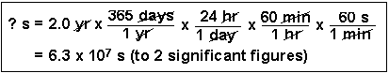

Scientists generally work in metric units. Common prefixes which we will be using are the following:

| **Prefix** | **Abbreviation** | **Meaning** | **Example** |
| --- | --- | --- | --- |
| kilo- | k | 103 | 1 kilogram (kg) = 1 x 103 g |
| centi- | c | 10**-**2 | 1 centimeter (cm) = 1 x 10**-**2 m |
| milli- | m | 10**-**3 | 1 milligram (mg) = 1 x 10**-**3 g |

(4) Convert 50.0 mL to liters. (This is a very common conversion.)

mr-da-5

(5) What is the density of mercury (13.6 g/cm3) in units of kg/m3?

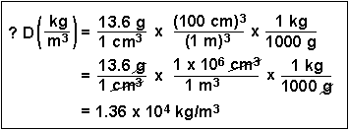

We also can use dimensional analysis for solving problems.

|  |  |
| --- | --- |
| **Question 1** | How many millimeters are present in 20.0 kilometers? |
| **Question 2** | The volume of a wooden block is 6.30 m3. This is equivalent to how many cubic centimeters? |

**Concepts and Skills Practice**

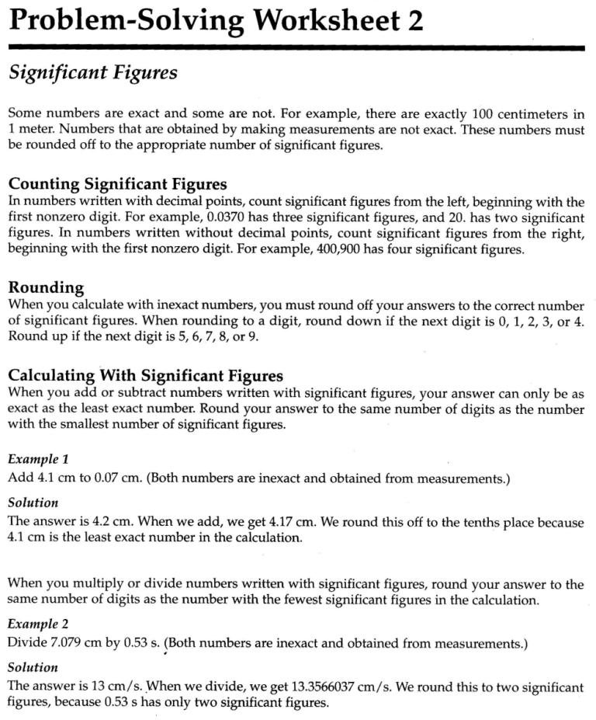

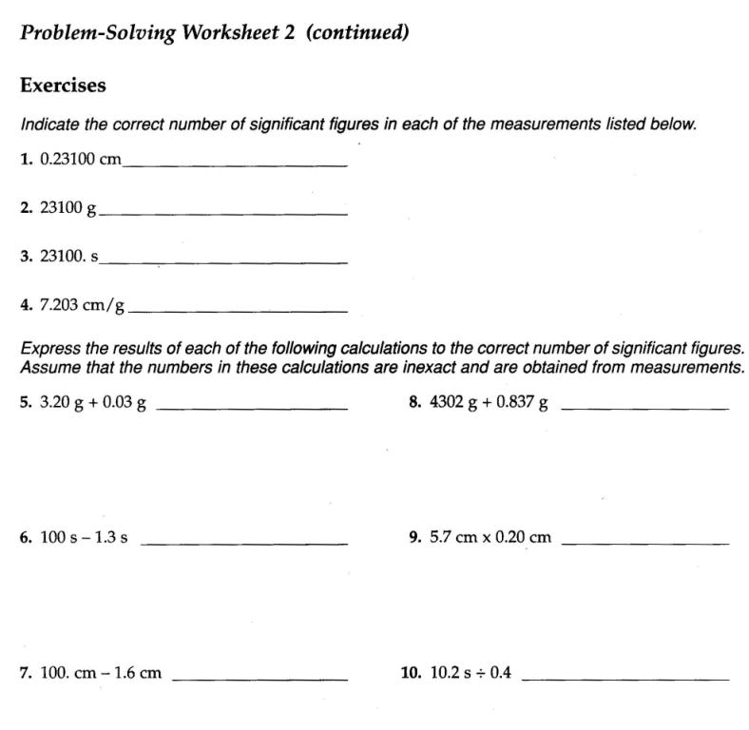

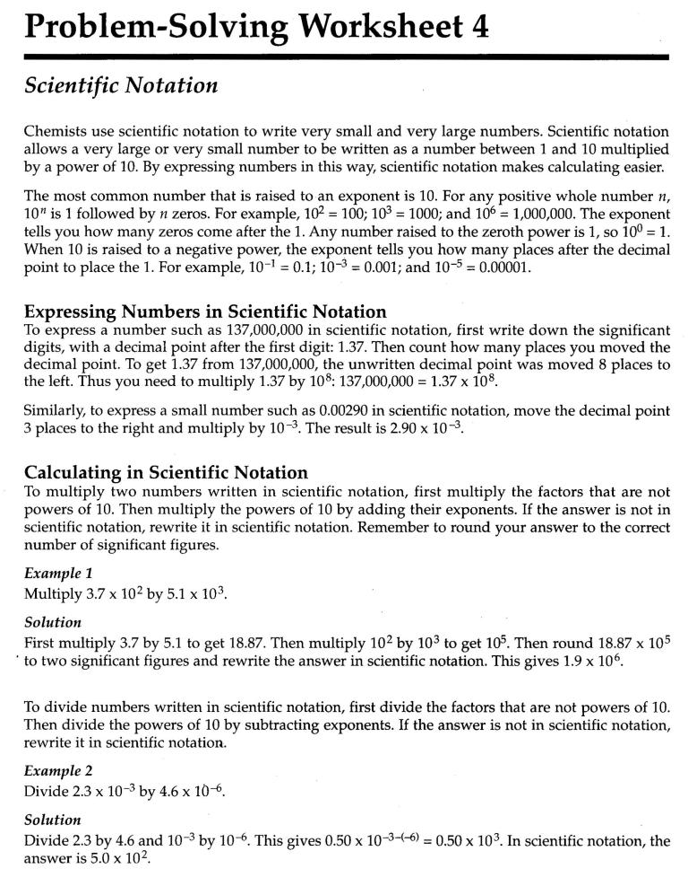

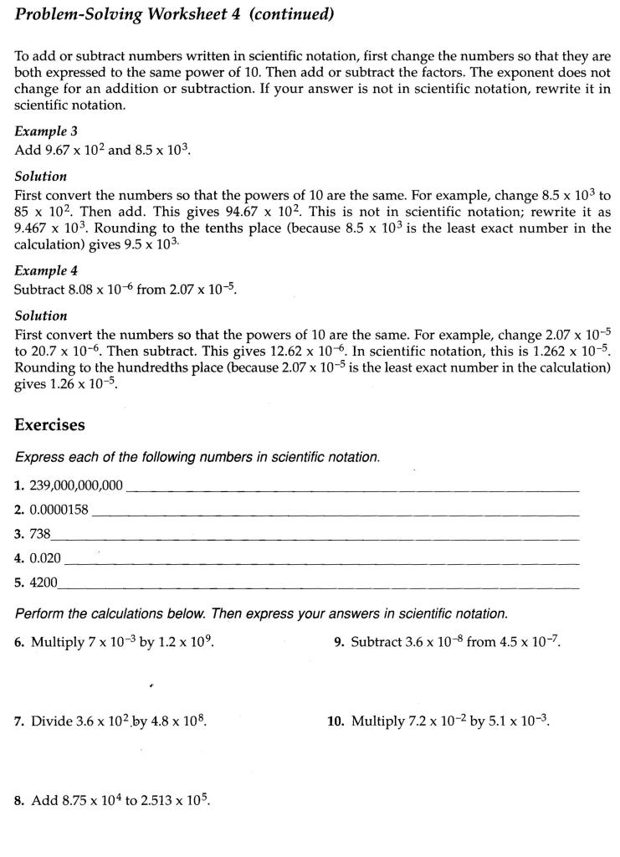

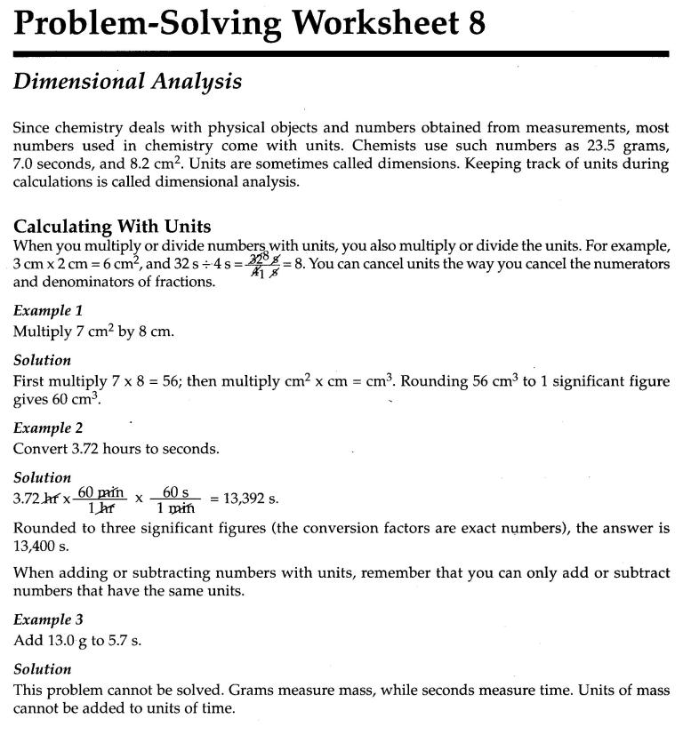

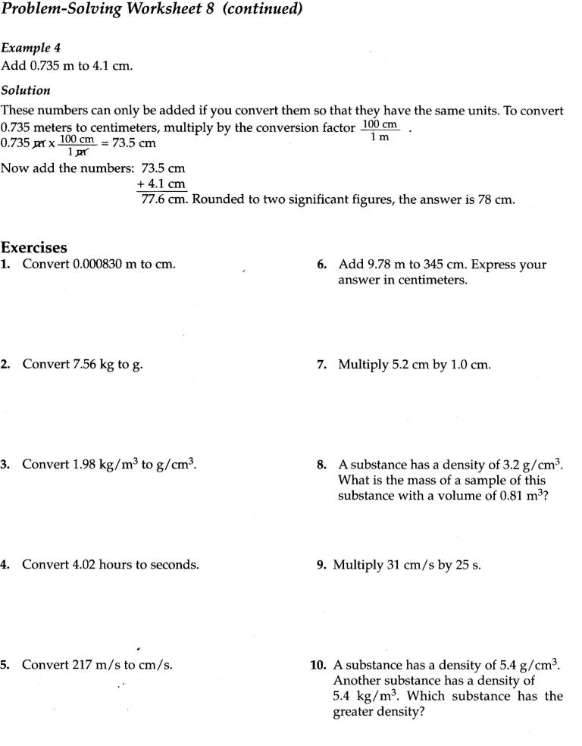

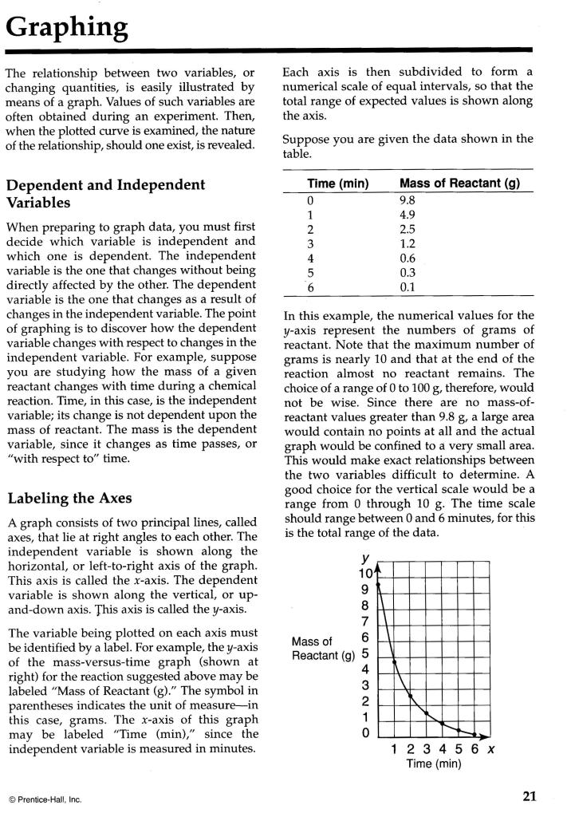

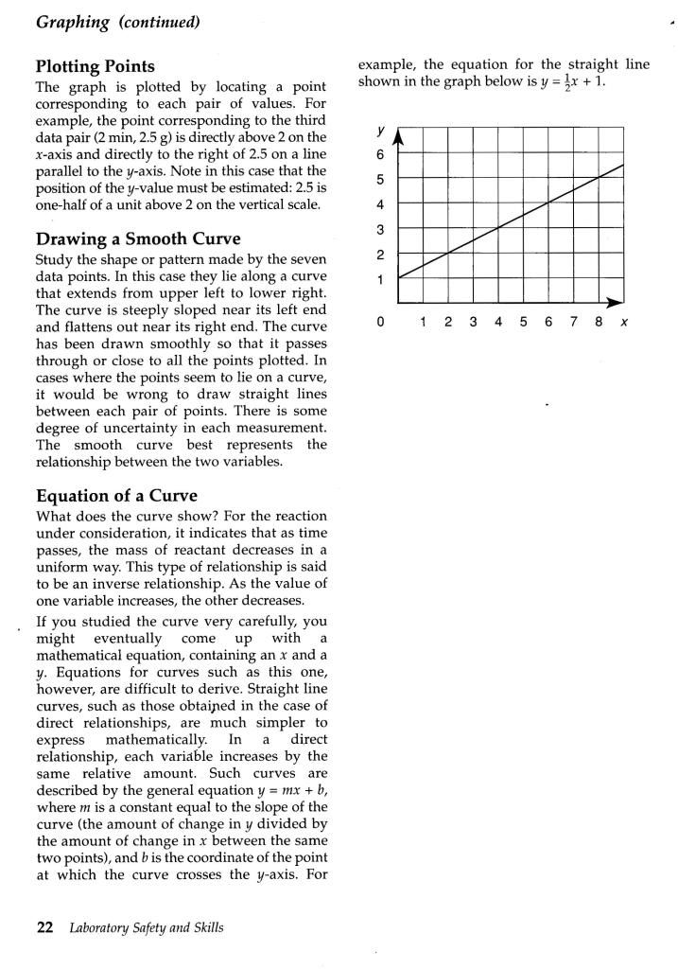

**Graphing Practice**

Study the power point slides on graphing. Follow the instructions there and plot the data in the table below on a piece of graph paper.

| Time (s) | Velocity (m/s) |
| --- | --- |
| 18 | 4.0 |
| 31 | 7.5 |
| 60. | 15.0 |
| 120. | 25.0 |
| 180. | 37.0 |
| 240. | 45.0 |
| 300. | 54.0 |

1. Draw a best-fit line.
2. Determine the slope of the line.
3. Estimate the y-intercept.
4. Write the equation of the line.

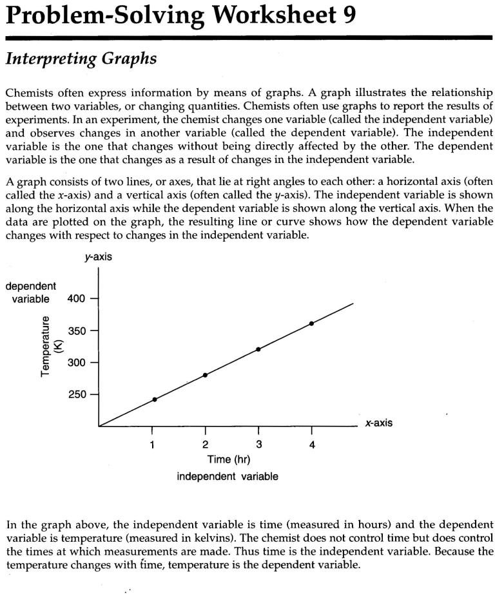

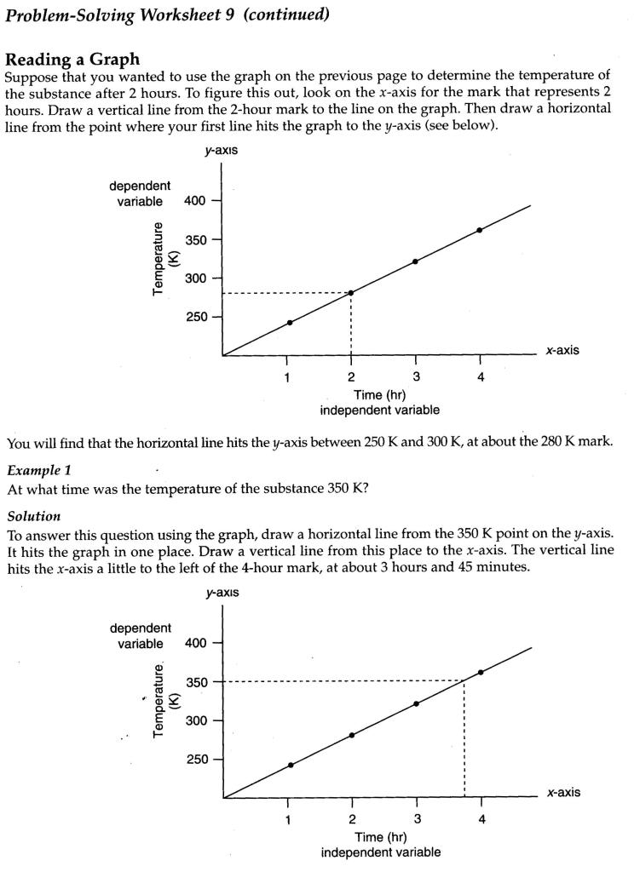 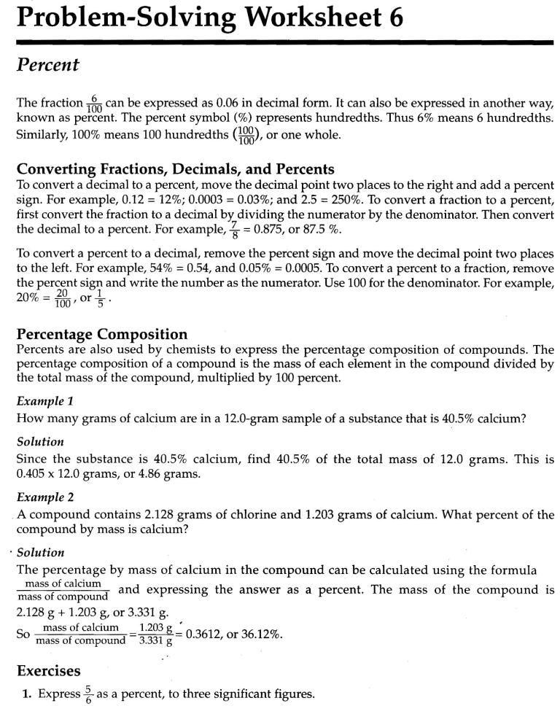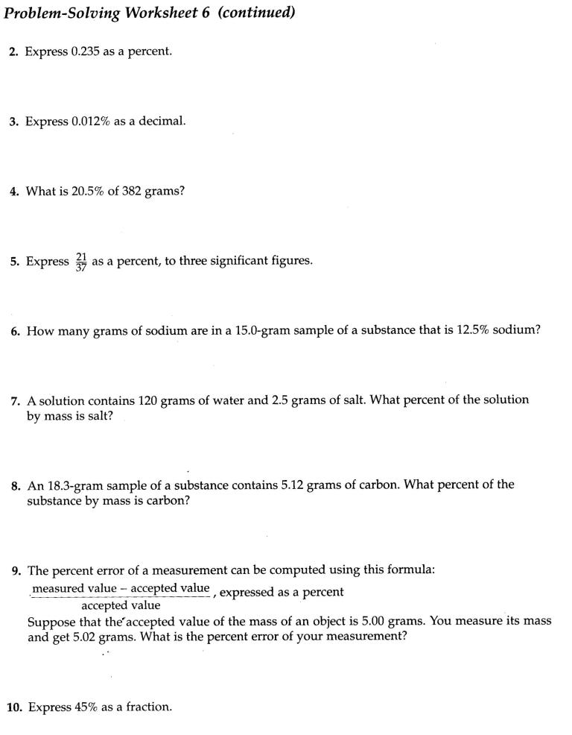

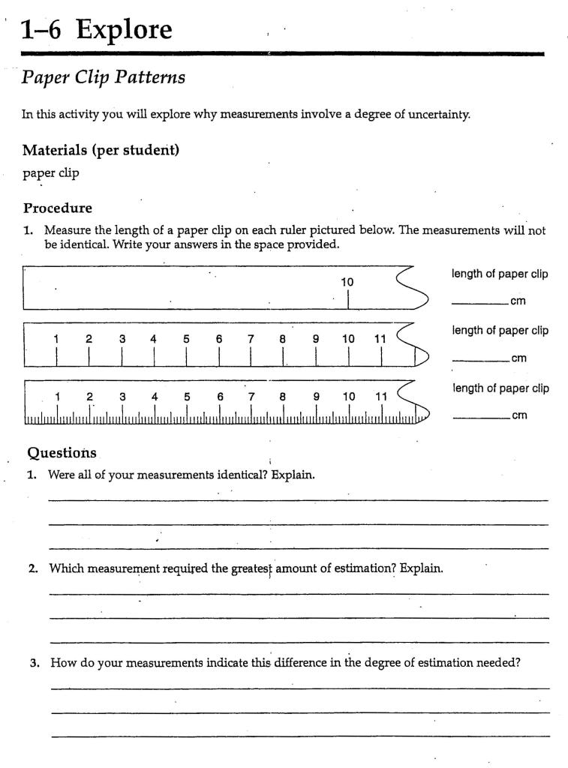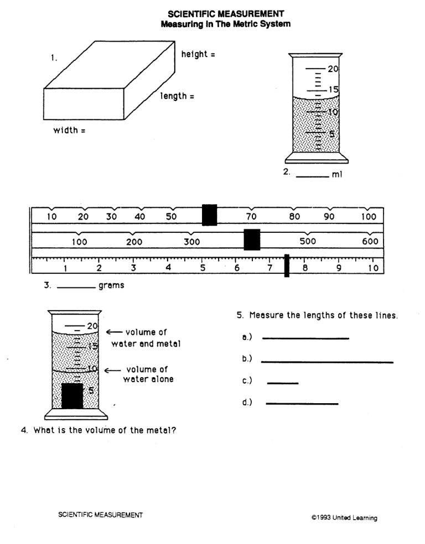

Unit 1: Worksheet 2 - Reading Scales

For each of the following, write the scale reading, then the number of significant figures in the reading.

**Reading SF’s**

1. image

2. image

3. image

4. image

5. image

6. image

7. image

8. image

Modeling Chemistry 3 U1 ws 2 v2.0

image

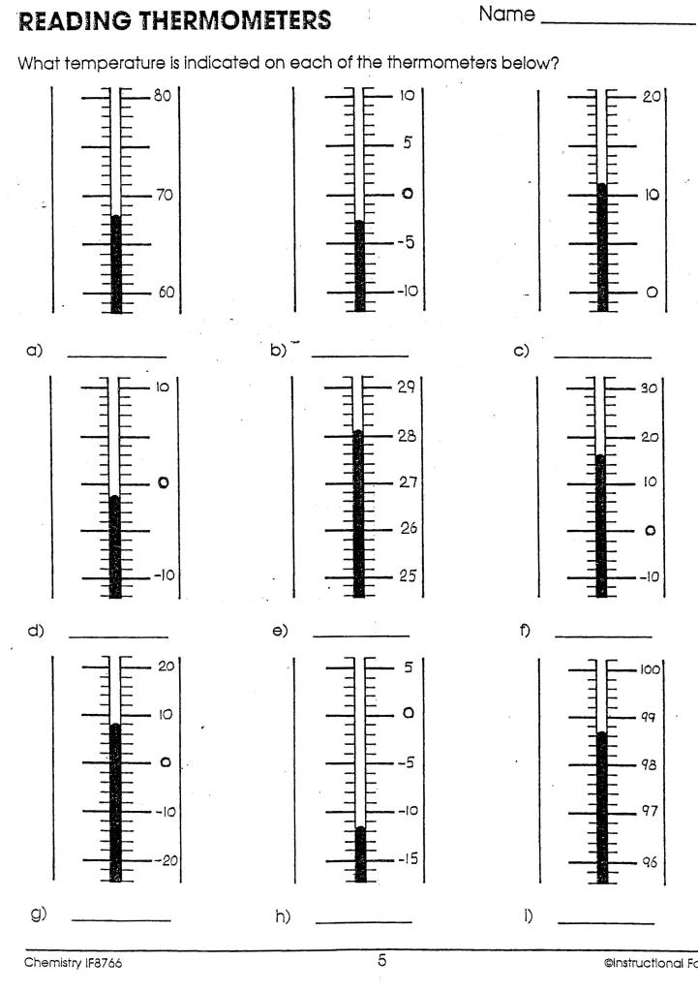

**Uncertainty in Measurements**

1. Why are measurements always uncertain?
2. Why is estimation a necessary part of making measurements?
3. An electronic balance shows the mass of a sample of sodium chloride to be 29.732 g. What is the uncertainty of measurement? In what range can the true value exist?

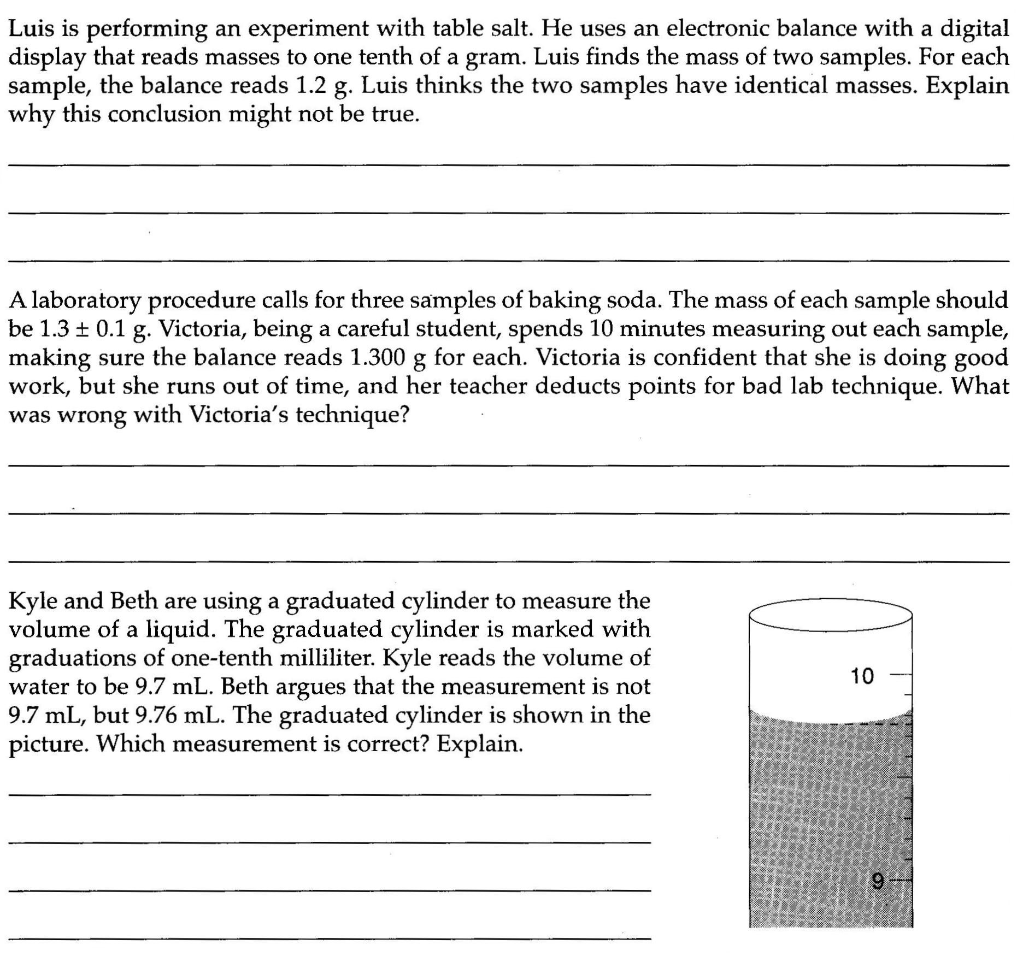

4.

5.

6.

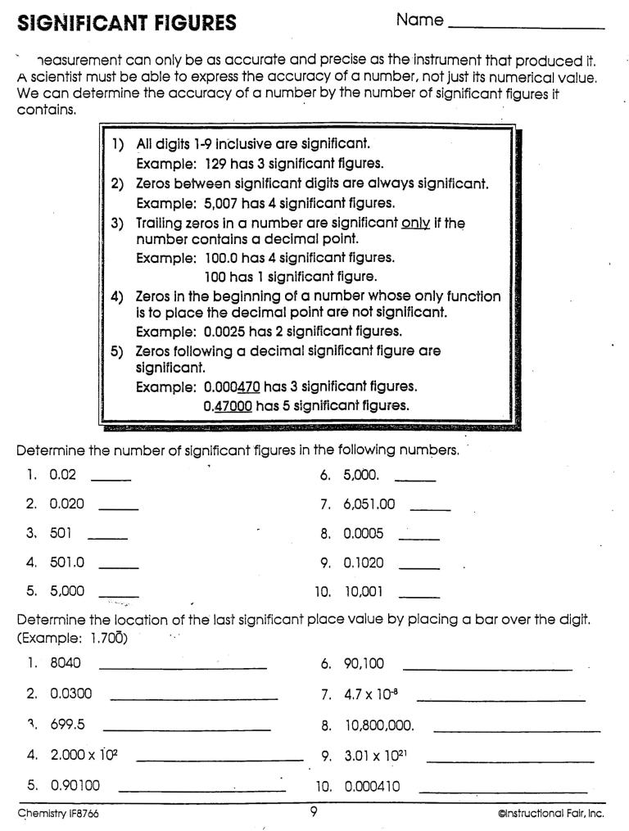

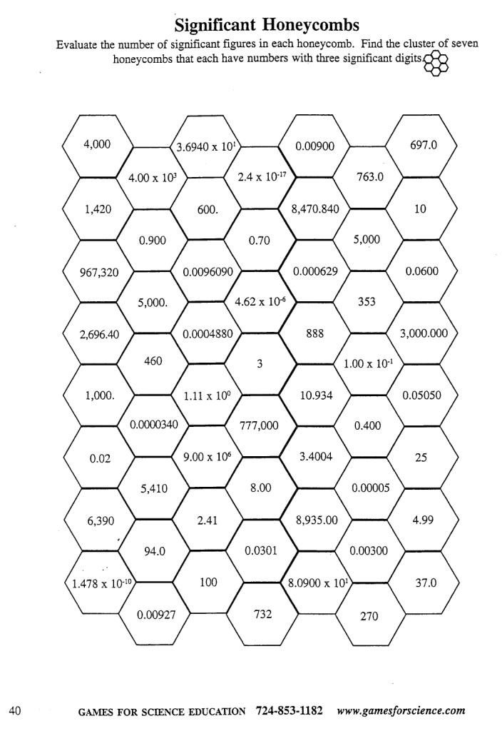

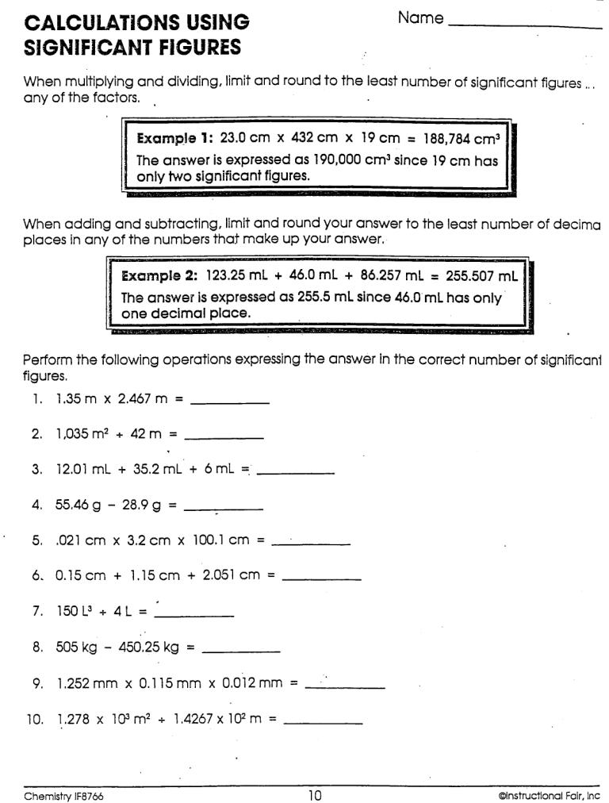

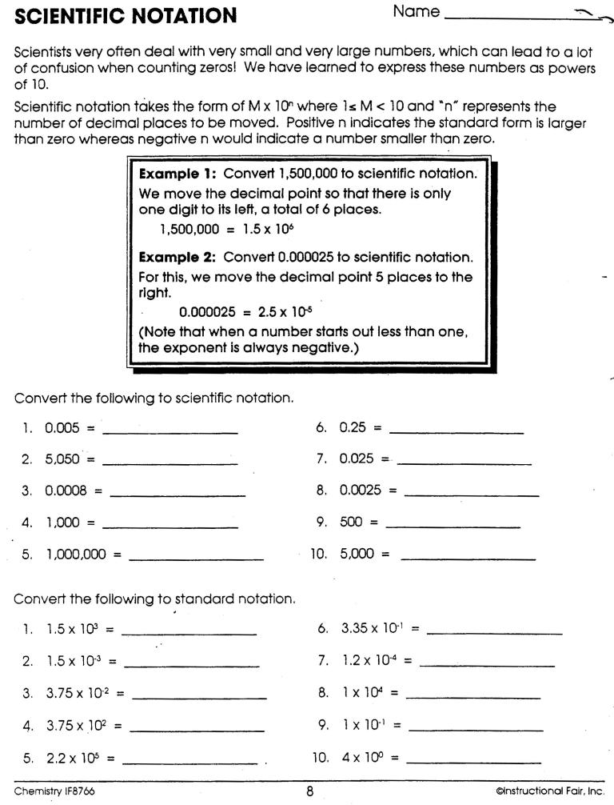

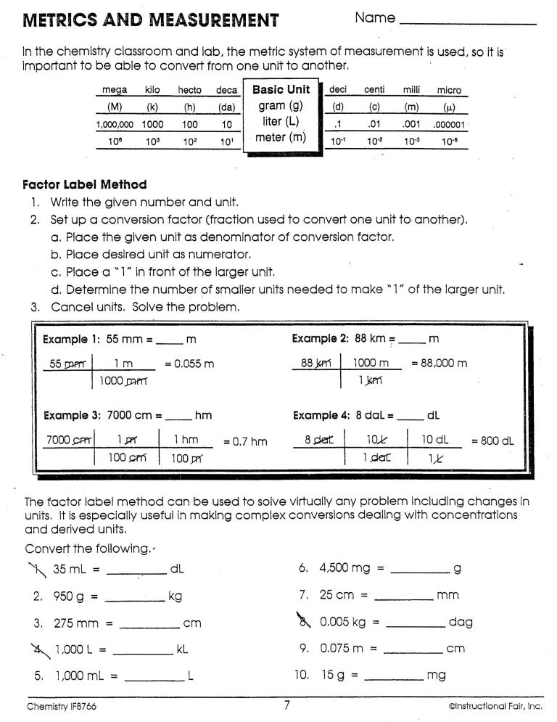Unit 1 - Worksheet 6 Dimensional Analysis

Use the factor-label method to make the following conversions. Remember to use the appropriate number of sf’s in your answer.

## Part 1

1. 74 cm x = meters

2. 8.32 x 10-2 kg x = grams

~~3. 55.5 mL x = cm3~~

4. 0.00527 cal x = kilocalories

5. 9.52 x 10-4 m x = micrometers

6. 41.0 mL x = liters

7. 6.0 x 10-1 g x = mg

8. 8.34 x 10-9 cg x = g

9. 5.0 x 103 mm x = m

10. 1.0 day x x x = seconds

11. 5.00 x 104 mm x x = km

12. 9.1 x 10-13 kg x x = ng

Modeling Chemistry U 1 ws 6 v2.0

13. 1.0 year x x = hours (approximately)

(assume 365 days a year)

14. 1.0 mile x x = inches

(Hint: 1 mile = 5280 feet)

## Part 2

1. How many nickels could you trade for 250 yen? $1 = 150 yen.

2. How many seconds in a year? (assume 365 days a year)

~~3. Chloroform is a liquid once used for anesthetic. What is the volume of 5.0 g of chloroform? The density of chloroform 1.49 g/mL~~

4. How many inches long is a football field (120 yards)?

5. How many mg is 59.0 kg? Express your answer in scientific notation.

6. How many m3 is 4.6 cm3.? Express your answer in scientific notation.

Modeling Chemistry U 1 ws 6 v2.0